Contents

Introduction 2

Task Definition 2

Mission 2

Contacts 2

News 2

Finance 3

Prices 3

Money Calculation 3

Diagram Flow 3

Term and Condition & Privacy 4

Conclusion 5

# Introduction

Marketing Advertisement have seen it on YouTube, Facebook and Google Ads giving curiosity of client’s products to the social media users. Google has dominated the space of advertising and selling to users but because of lack of business can adversely affect it is lost, where they would not know where to start with advertising. AI is an automation to people but a lost moment for human money flowage.

## Task Definition

To assist people who seek money method products and struggle to make money because they would not know where to begin at. I Lolwethu Damane wish to be rich but not rich alone, this SAAS is to try to help with the biggest problem in the world and that would be money. We are a marketing advertisement SAAS on which we assist the client’s product to rally up to their interest and preference, the middleman is the one who will sell the idea to their family and friends. When there is a marketing production to the client is where we will pay out the middleman. Middleman could advertise as well for clients. Our service will be conducted online on website first then towards that it will go on to software and hopefully I can get the profit for site to run with minimum bottleneck.

## Mission

Try to help with the biggest problem in the world and that would be money. We assist the client’s product to rally up to their interest and preference, the middleman is the one who will sell the idea to their family and friends. Allow new members to gain experience and knowledge about marketing advertising.

## Contacts

Contacts:

Email

Users will insert into edit box with them

**name, surname, problem, email and send**.[OF]

Socials: **YouTube, X, TikTok, Facebook, Instagram**

## News

Show latest special deal for clients, middlemen, customer and advertisers to the software/website. Have a shopping site on where the company bought will assist continue contribution on and more. Any updates or issues should be given too.

# Finance

## Prices

Client Premium: $?

* Having discount deals on advertisements
* Personal Assistance push product
* Own financial bot

Middlemen Premium: $6/m $60/y

* Provide new user members for them monthly/ quarterly
* Any new feed will be provided to them early access
* *Minimum automation feature
* Level up multiplier

## Money Calculation

Client pays my company to advertise

Middleman= our advertisers

Problem: People can click and use the software, but clients do not receive profit from our engagement, how to fix

Solution: Profit for the middleman is only given based on the number of clickers(small money) and for those who buy the client product(big money)

E.g.: **$100**

700 Clicked users: $1

$100 x 0,07clicks = 7users might buy… Something like that

Customers buy the client’s product: $5

Client product is $10

The company cut in the total was used is $25 || 25%

## Diagram Flow

Middlemen progress will be measure through level advertisement (xp).

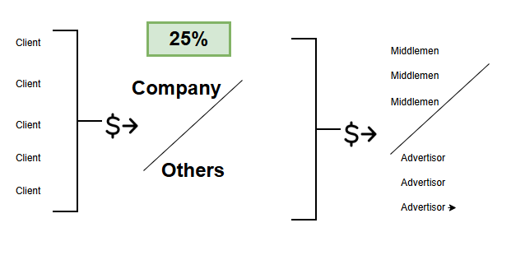

# Term and Condition & Privacy

Minimum age should be 16 years old and older

Privacy will be a problem, always one will want control…iykyk

Do not trust links that does not link directly to site or application…spread it

Money will not be transferred completely till certain hours because of scams

Make a complain policy where things will be investigated and not just banned, but temporarily yes.

Middlemen/ advertiser Copyright policy on copying logo, advertising video, picture or product.

Use a law in your website if necessary to what is required on popi act and esc.

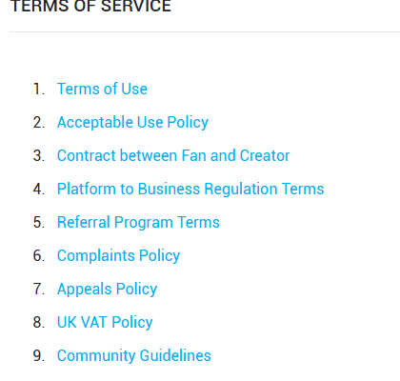

# Conclusion

**CHATGPT**

Marketing and advertising for SaaS (Software as a Service) businesses require a strategic, multi-channel approach that integrates both traditional and digital marketing tactics. Given the unique nature of SaaS—where customer acquisition and retention are paramount—it is essential to build a marketing and advertising strategy that not only attracts prospects but also drives long-term customer engagement and satisfaction. Ongoing optimization to drive both acquisition and retention. By maintaining a customer-centric mindset and utilizing the right tools and strategies, SaaS companies can build a sustainable and profitable marketing engine.